## 2023 Consumer Confidence Report for Public Water System CHALK BLUFF WSC

This is your water quality report for January 1 to December 31, 2023

CHALK BLUFF WSC provides ground water from **The Southern Trinity Aquifer** located in **Mclennan County.**

For more information regarding this report contact:

Name Kevin Lander Phone 254-799-1268

Este reporte incluye informacion importante sabre el agua para tomar. Para asistencia en espaiiol, favor de

llamar al telefono {254) 799-1268.

**Definitions and Abbreviations**

Definitions and Abbreviations Action Level:

The following tables contain scientific terms and measures, some of which may require explanation.

The concentration of a contaminant which, if exceeded, triggers treatment or other requirements which a water system must follow.

Avg: Regulatory compliance with some MCLs are based on running annual average of monthly samples.

Level 1 Assessment:

A Level 1 assessment is a study of the water system to identify potential problems and determine (if possible) why total coliform bacteria have been found in our water svstem.

Level 2 Assessment: A Level 2 assessment is a very detailed study of the water system to identify potential problems and determine (if possible) why an E.coli MCL violation has occurred and/or whv total coliform bacteria have been found in our water svstem on multiole occasions.

Maximum Contaminant Level or MCL: The highest level of a contaminant that is allowed in drinking water. MCLs are set as close to the MCLGs as feasible using the best available treatment technology.

Maximum Contaminant Level Goal or MCLG: The level of a contaminant in drinking water below which there is no known or expected risk to health. MCLGs allow for a margin of safety.

Maximum residual disinfectant level or MRDL: The highest level of a disinfectant allowed in drinking water. There is convincing evidence that addition of a disinfectant is necessary for control of microbial contaminants.

Maximum residual disinfectant level goal or MRDLG: The level of a drinking water disinfectant below which there is no known or expected risk to health. MRDLGs do not reflect the benefits of the use of disinfectants to control microbial contaminants.

MFL million fibers per liter (a measure of asbestos)

mrem: millirems per year (a measure of radiation absorbed by the body)

na: not applicable.

NTU nephelometric turbidity units (a measure of turbidity)

pCi/L picocuries per liter (a measure of radioactivity)

**Definitions and Abbreviations**

ppb:

ppm:

ppq ppt

Treatment Technique or TT:

micrograms per liter or parts per billion milligrams per liter or parts per million

parts per quadrillion, or picograms per liter (pg/L) parts per trillion, or nanograms per liter (ng/L)

A required process intended to reduce the level of a contaminant in drinking water.

**Information about your Drinking Water**

The sources of drinking water {both tap water and bottled water) include rivers, lakes, streams, ponds, reservoirs, springs, and wells. As water travels over the surface of the land or through the ground, it dissolves naturally-occurring minerals and, in some cases, radioactive material, and can pick up substances resulting from the presence of animals or from human activity.

Drinking water, including bottled water, may reasonably be expected to contain at least small amounts of some contaminants. The presence of contaminants does not necessarily indicate that water poses a health risk. More information about contaminants and potential health effects can be obtained by calling the EPAs Safe Drinking Water Hotline at {800) 426-4791.

Contaminants that may be present in source water include:

* Microbial contaminants, such as viruses and bacteria, which may come from sewage treatment plants, septic systems, agricultural livestock operations, and wildlife.
* Inorganic contaminants, such as salts and metals, which can be naturally-occurring or result from urban storm water runoff, industrial or domestic wastewater discharges, oil and gas production, mining, or farming.
* Pesticides and herbicides, which may come from a variety of sources such as agriculture, urban storm water runoff, and residential uses.
* Organic chemical contaminants, including synthetic and volatile organic chemicals, which are by-products of industrial processes and petroleum production, and can also come from gas stations, urban storm water runoff, and septic systems.
* Radioactive contaminants, which can be naturally-occurring or be the result of oil and gas production and mining activities.

In order to ensure that tap water is safe to drink, EPA prescribes regulations which limit the amount of certain contaminants in water provided by public water systems. FDA regulations establish limits for contaminants in bottled water which must provide the same protection for public health.

Contaminants may be found in drinking water that may cause taste, color, or odor problems. These types of problems are not necessarily causes for health concerns. For more information on taste, odor, or color of drinking water, please contact the system's business office.

You may be more vulnerable than the general population to certain microbial contaminants, such as Cryptosporidium, in drinking water. Infants, some elderly, or immunocompromised persons such as those undergoing chemotherapy for cancer; persons who have undergone organ transplants; those who are undergoing treatment with steroids; and people with HIV/AIDS or other immune system disorders, can be particularly at risk from infections. You should seek advice about drinking water from your physician or health care providers. Additional guidelines on appropriate means to lessen the risk of infection by Cryptosporidium are available from the Safe Drinking Water Hotline {800-426-4791).

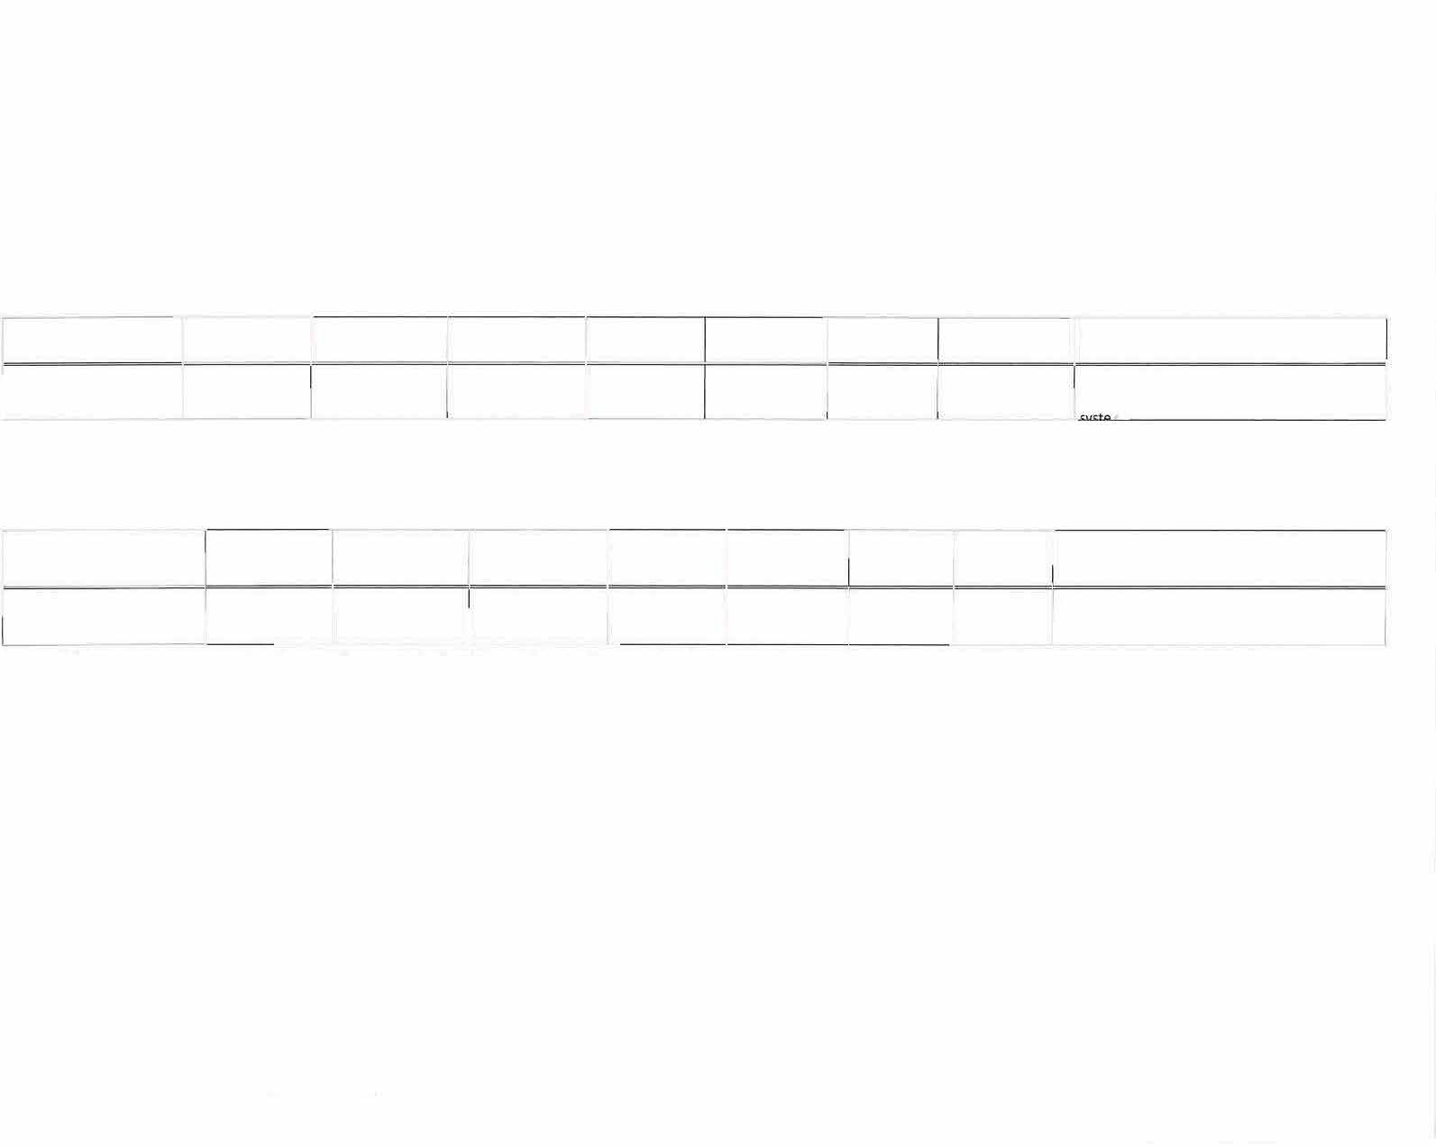If present, elevated levels of lead can cause serious health problems, especially for pregnant women and young children. Lead in drinking water is primarily from materials and components associated with service lines and home plumbing. We are responsible for providing high quality drinking water, but we cannot control the variety of materials used in plumbing components. When your water has been sitting for several hours, you can minimize the potential for lead exposure by flushing your tap for 30 seconds to 2 minutes before using water for drinking or cooking. If you are concerned about lead in your water, you may wish to have your water tested. Information on lead in drinking water, testing methods, and steps you can take to minimize exposure is available from the Safe Drinking Water Hotline or at [http://www.epa.gov/safewater/lead.](http://www.epa.gov/safewater/lead)

## Information about Source Water

TCEQ completed an assessment of your source water, and results indicate that some of our sources are susceptible to certain contaminants. The sampling requirements for your water system is based on this susceptibility and previous sample data. Any detections of these contaminants will be found in this Consumer Confidence Report. For more information on source water assessments and protection efforts at our system contact **Kevin Lander, 254-799-1268.**

|  |  |  |  |  |  |  |
| --- | --- | --- | --- | --- | --- | --- |
| **Lead and Copper** | **Date Sampled** | **MCLG** | **Action Level (AL)** | **90th Percentile # Sites Over AL** | **Units Violation** | **Likely Source of Contamination** |
| **Copper** | 2023 | |  | 0.1611 0 | ppm N Erosion of natural deposits; Leaching from wood | |
|  |  |  | prese-rv-atives; Corrosion of household plumbing |

**2023 Water Quality Test Results**

1.3

1.3

|  |  |  |  |  |  |  |  |  |
| --- | --- | --- | --- | --- | --- | --- | --- | --- |
| **Disinfection By-Products** | **Collection Date** |  |  | **MCLG** | **MCL** | **Units** | **Violation** | **Likely Source of Contamination** |
| **Total Trihalomethanes (TTHM)** | 2023 |  |  | No goal for the | 80 | ppb | N | By-product of drinking water disinfection. |
|  |  |  |  | total |  |  |  |  |

*The value in the Highest Level or Average Detected column is the highest average of all TTHM sample results collected at a location over a year

|  |  |  |
| --- | --- | --- |
|  | **Highest Level Detected** | **Range of Individual Samples** |
| 6 5.7-5.7 | |
|  |  |

# 06/03/2024 - TX1550020_2023_2024-06-03_12-06-12.DOC 5 of 7

|  |  |  |  |  |  |  |  |  |
| --- | --- | --- | --- | --- | --- | --- | --- | --- |
| **Inorganic Contaminants** | **Collection Date** | **Highest Level Detected** | **Range of Individual Samples** | **MCLG** | **MCL** | **Units** | **Violation** | **Likely Source of Contamination** |
| **Arsenic** | **09/08/2022** | **2** | **0-2** | **0** | **10** | **ppb** | **N** | **Erosion of natural deposits; Runoff from orchards; Runoff from glass and electronics production wastes.** |
| **Barium** | **09/08/2022** | **0.0544** | **0.0537 - 0.0544** | **2** | **2** | **ppm** | **N** | **Discharge of drilling wastes; Discharge from metal refineries; Erosion of natural deposits.** |
| **Fluoride** | **2023** | **1.5** | **0.65- 1.5** | **4** | **4.0** | **ppm** | **N** | **Erosion of natural deposits; Water additive which promotes strong teeth; Discharge from fertilizer and**  **-I. _:_ ,m f..,r+,.,riPC:::** |
| **Nitrate [measured as Nitrogen)** | **2023** | **0.15** | **0.06- 0.15** | **10** | **10** | **ppm** | **N** | **Runoff from fertilizer use; Leaching from septic tanks, sewage; Erosion of natural deposits.** |
| **Selenium** | **09/08/2022** | **4.9** | **3.4-4.9** | **so** | **so** | **ppb** | **N** | **Discharge from petroleum and metal refineries; Erosion of natural deposits; Discharge from mines.** |

|  |  |  |  |  |  |  |  |  |
| --- | --- | --- | --- | --- | --- | --- | --- | --- |
| **Radioactive Contaminants** | **Collection Date** | **Highest Level Detected** | **Range of Individual Samples** | **MCLG** | **MCL** | **Units** | **Violation** | **Likely Source of Contamination** |
| Combined Radium 226/228 | 06/16/2021 | 1.5 | 1.5-1.S | 0 | s | pCi/L | N | Erosion of natural deposits. |

|  |  |  |  |  |  |  |  |  |
| --- | --- | --- | --- | --- | --- | --- | --- | --- |
| Volatile Organic Contaminants | Collection Date | Highest Level Detected | Range of Individual Samples | MCLG | MCL | Units | Violation | Likely Source of Contamination |
| Xylenes | 2023 | 0.0021 | 0-0.0021 | 10 | 10 | ppm | N | Discharge from petroleum factories; Discharge from chemical factories. |

**Disinfectant Residual**

**A blank disinfectant residual table has been added to the CCR template, you will** need **to add data to the fields. Your data can be taken off the Disinfectant Level Quarterly Operating Reports (DLQOR).**

|  |  |  |  |  |  |  |  |  |
| --- | --- | --- | --- | --- | --- | --- | --- | --- |
| Disinfectant Residual | **Year** | Average Level | Range of Levels Detected | MRDL | MRDLG | Unit of Measure | Violation (Y/N) | Source in Drinking Water |
| Free Chlorine | 2023 | 1.80 | .81 - 2.80 | 4 | 4 | Mg/L | N | Water additive used to control microbes. |

|  |  |  |  |  |  |
| --- | --- | --- | --- | --- | --- |
| Unregulated  Contaminant | Collection  Date | Average Level  (ug/L) | Range of Levels  Detected (ug/L) | Health-Based Reference  Concentration (ug/L) | Health Information Summary |
| Lithium | 2023 | 81.92 | 76.6 – 86.2 | 10 | This data is part of UCMR5  results in relation to minimum  reporting levels and available  non-regulatory health-based  reference concentrations**.** |

06/03/2024 - TX1550020_2023_2024-06-03_12-06-12.DOC 6 of 7